**GARAGE MANAGEMENT SYSTEM**

**TEAM MEMBERS:**

**R.SOPIYA-922222104043**

**R.SUNA-922222104046**

**R.YAMUNA DEVI-922222104054**

**K.KAVIPRIYA-922222104023**

**1.Project Overview**

Garage Management System is a Salesforce-based solution designed to modernize and automate traditional garage operations. By leveraging the powerful capabilities of Salesforce, the system efficiently manages customer details, vehicle records, service requests, mechanic assignments, and billing—all in one centralized platform. This initiative aims to enhance service efficiency, reduce manual errors, and provide real-time insights through dashboards and automation, ultimately improving customer satisfaction and optimizing overall garage performance.

**2. Objectives**

The objective of the Garage Management System is to develop a cloud-based platform using Salesforce that simplifies and automates garage operations. It aims to efficiently manage customer and vehicle information, track service requests, assign mechanics, and generate invoices—all within a unified system. By integrating automation and real-time reporting, the project seeks to enhance operational efficiency, minimize manual work, and deliver a seamless and transparent service experience for both customers and garage owners.

**Business Goals:**

**A.** **Automate Garage Operations** – Digitize key processes like customer management, service tracking, mechanic assignment, and billing using Salesforce automation.

**B.** **Improve Efficiency and Accuracy** – Reduce manual errors and time delays by maintaining all records and workflows in a centralized cloud platform.

**C.** **Enhance Customer Experience** – Provide timely service updates, transparent billing, and quick response to customer requests.

**D.Support Business Growth** – Enable data-driven insights through reports and dashboards to boost productivity, profitability, and scalability.

**3. Salesforce Key Features and Concepts Utilized**

The **Garage Management System** uses key Salesforce features like **Custom Objects**, **Flows**, and **Automation Tools** to manage customers, vehicles, and services efficiently. **Validation Rules** ensure data accuracy, while **Reports and Dashboards** provide real-time insights. **Email Alerts** improve customer communication, and **Security Controls** protect data integrity.

**Creating developer account**

•I created my developer account using the link below

<https://www.salesforce.com/form/developer-signup/?d=pb>

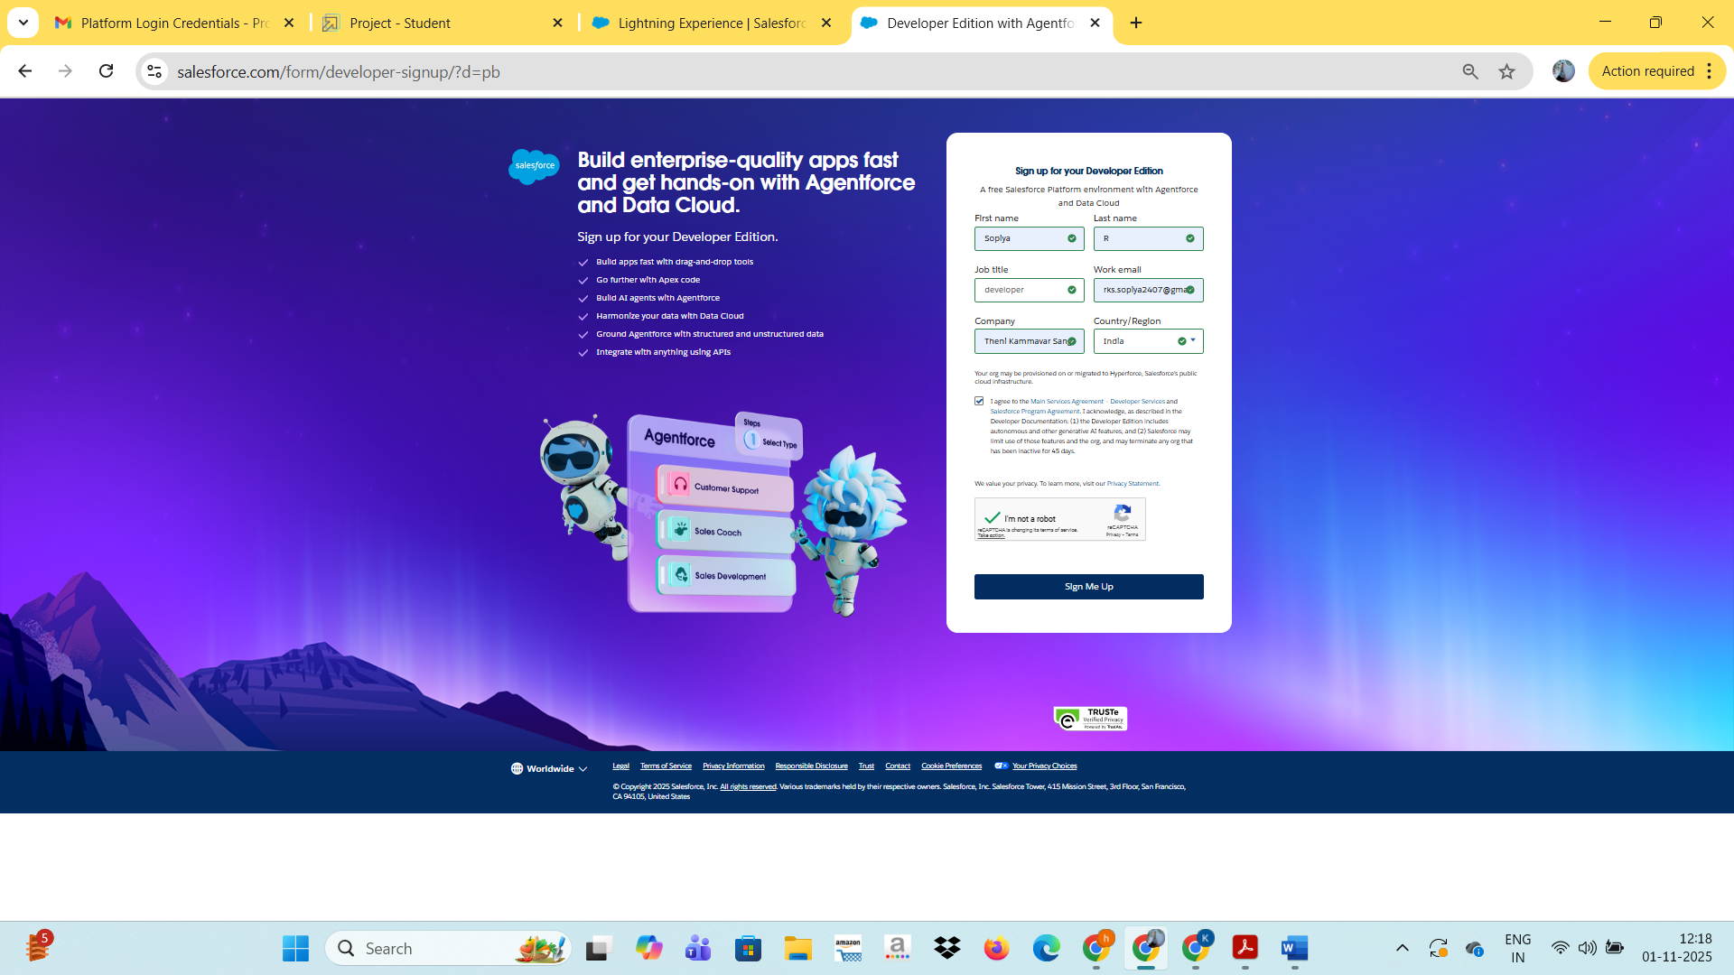

**Object:**

To create an object:

From the setup page >> Click on Object Manager >> Click on Create >>Click on Custom Object.

1.Appoinments.

2.Billing details and feedback.

3.Customer Details.

4.Service Records.

**Tabs:**

1. Go to setup page >> type Tabs in Quick Find bar >> click on tabs >> New (under custom object tab)

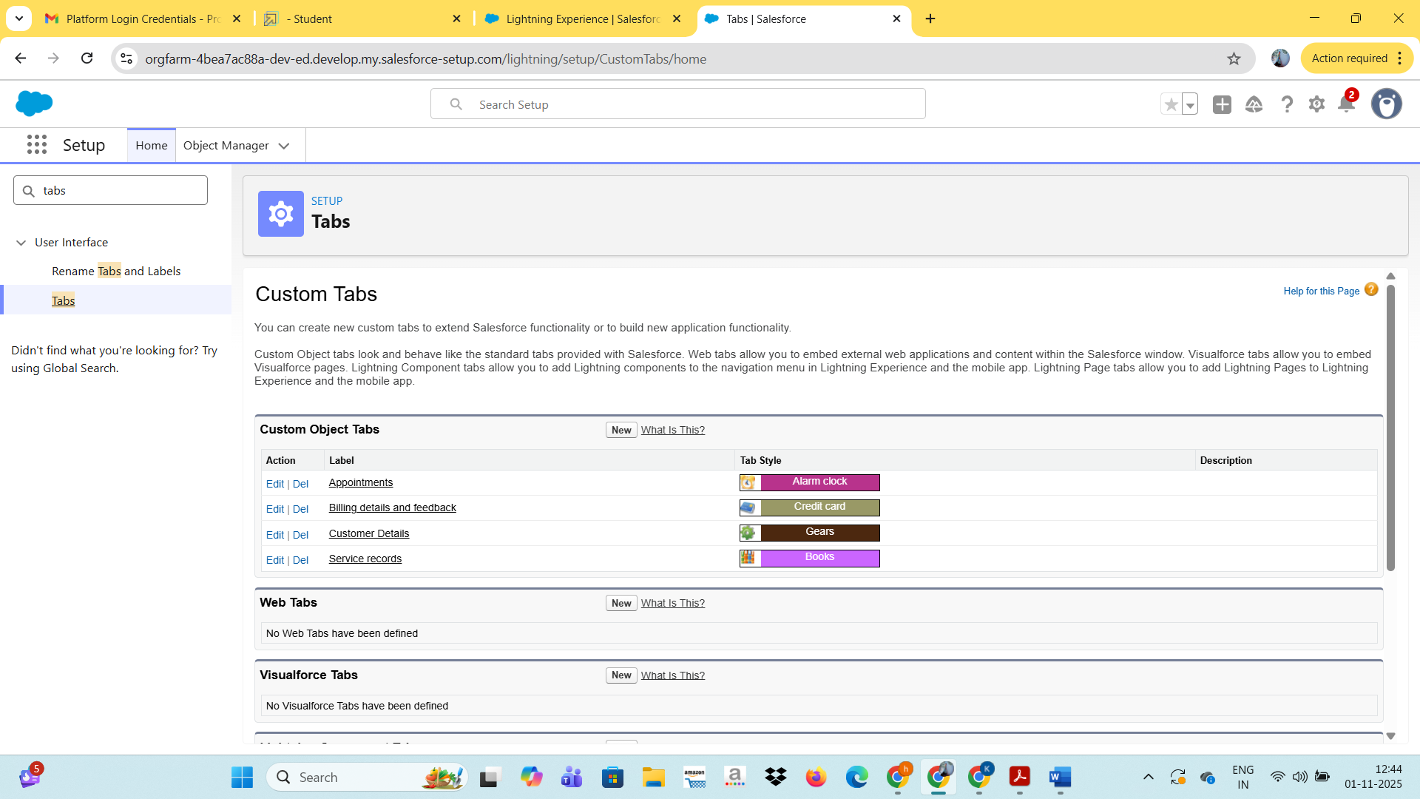

Now creating the tabs for the remaining objects, they are “ appointments, service records, billing details and feedback”

**The Lightning App:**

To create a lightning app page:

1. Go to setup page >> search “app manager” in quick find >> select “app manager” >> click on New lightning App.

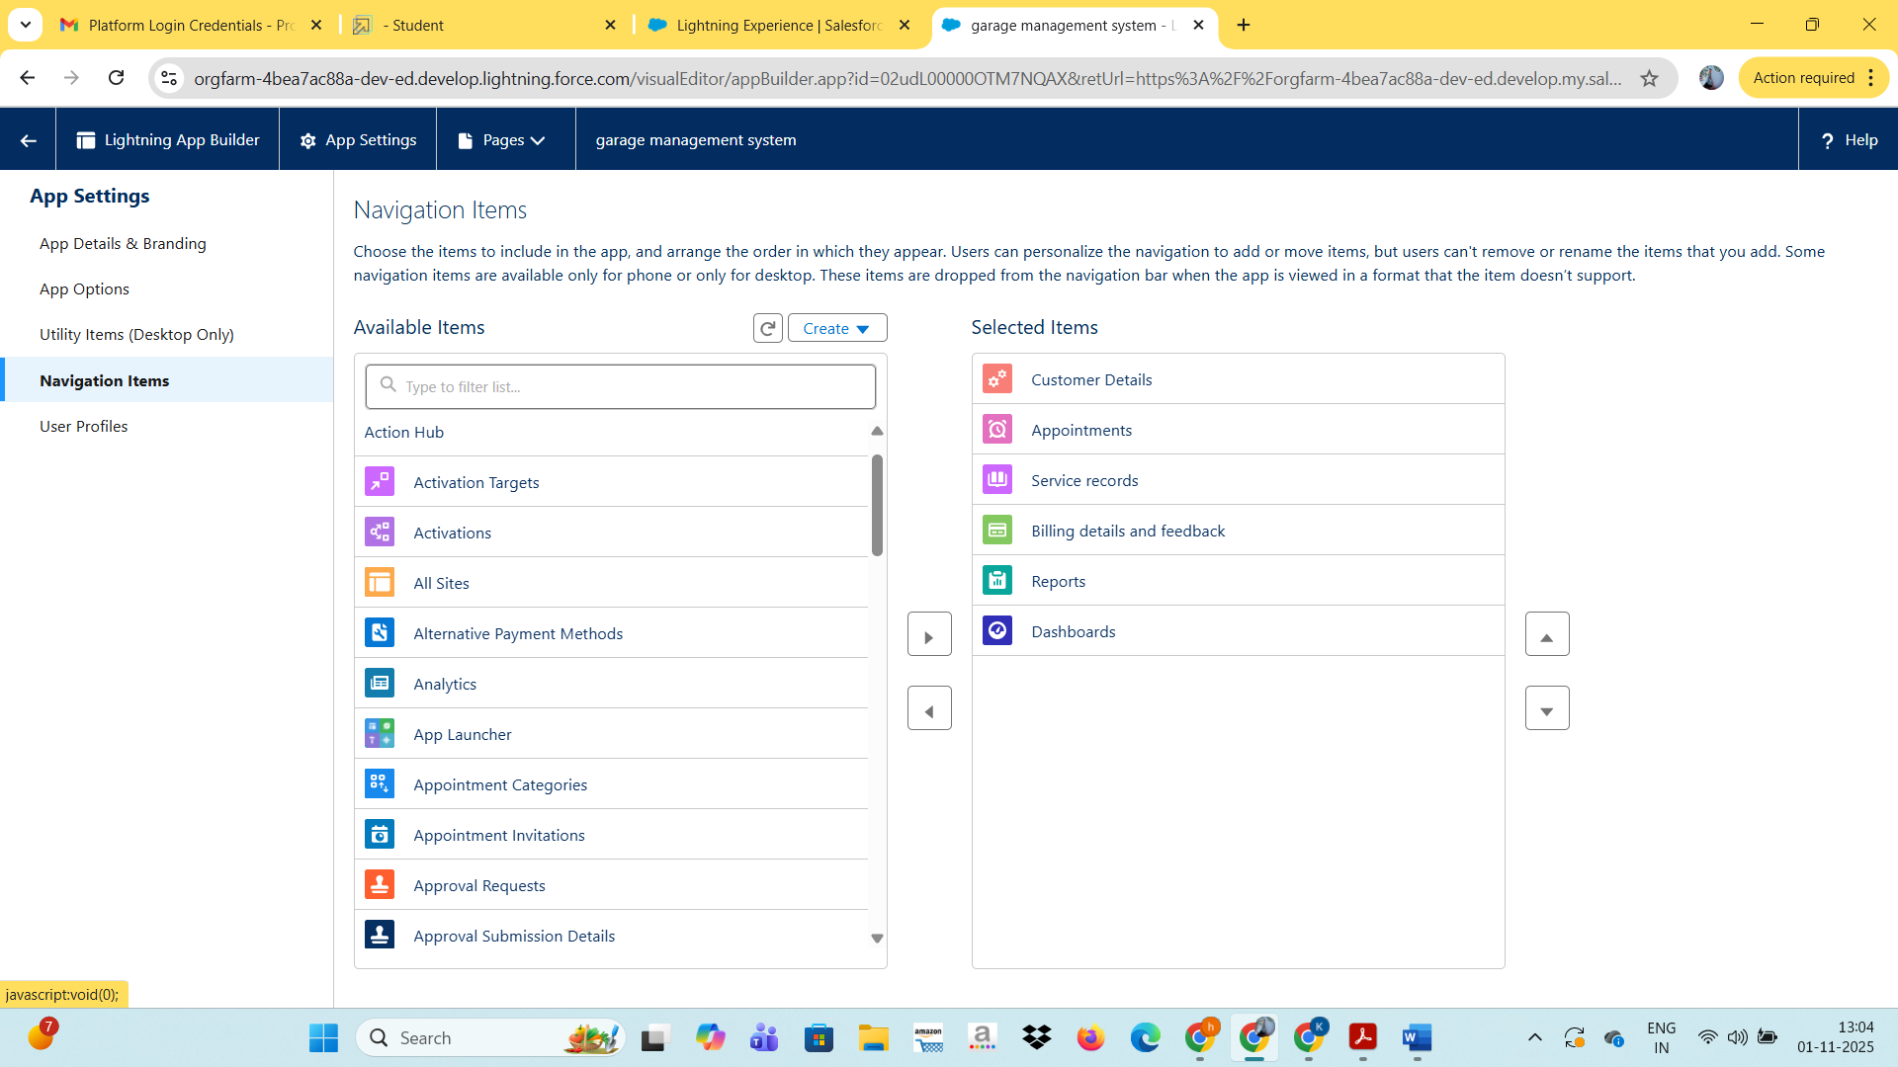

**Fields:**

**Creation of Relationship fields in objects:**

1. Go to setup >> click on Object Manager >> type object name(Customer Details) in search bar >> click on the object.

### Creation of fields for the Customer Details object

### 1.gmail.

### 2.phone no.

### 3.owner.

### 

### Creation of fields for the Appointment Object:

### 1.appoinment name.

### 2.Date.

### 3.Appointments

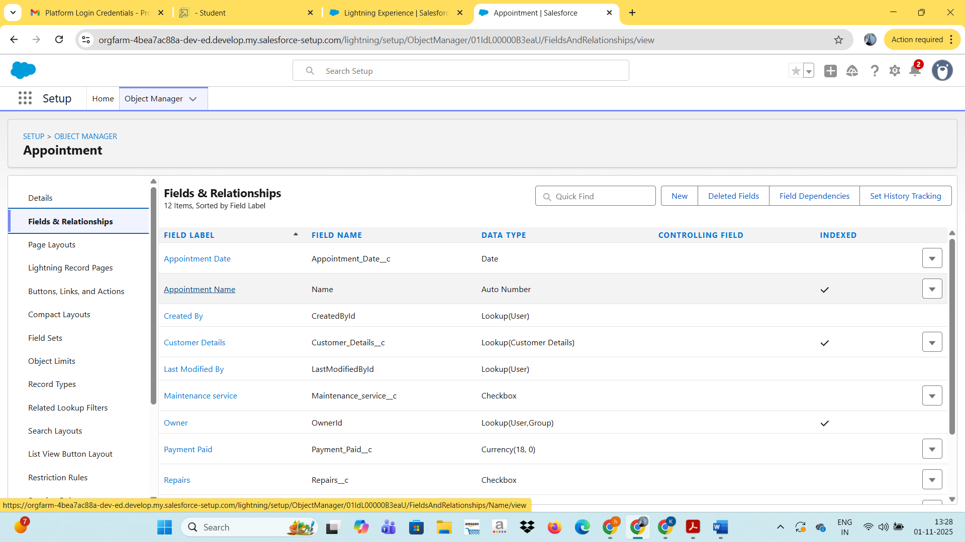

### Creation of fields for the Service records Object

### 1.service date

### 2.service records name

### 3.service status

### 

### Creation of fields for the billing details and feedback object

1.billing details and feedback name

2.payment paid

3.payment status

4.rating for service

5.service records

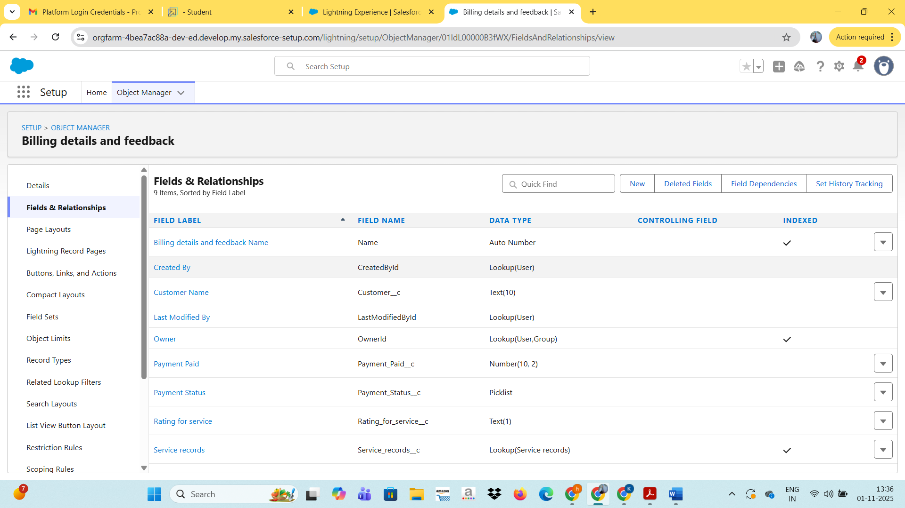

**FLOWS:**

Create a flow to create a record in object

Go to setup  >>  type Flow in quick find box  >>  Click on the Flow and Select the New Flow.

Select the record trigger flow. And select,

1.Record trigger flow

2.Billing details and feedback

3.Actions and related records

4.update and creating other records

Under the Record-triggered Flow Click on “+” Symbol and In the Drop down List select the “Update records Element

Now the flow as ,

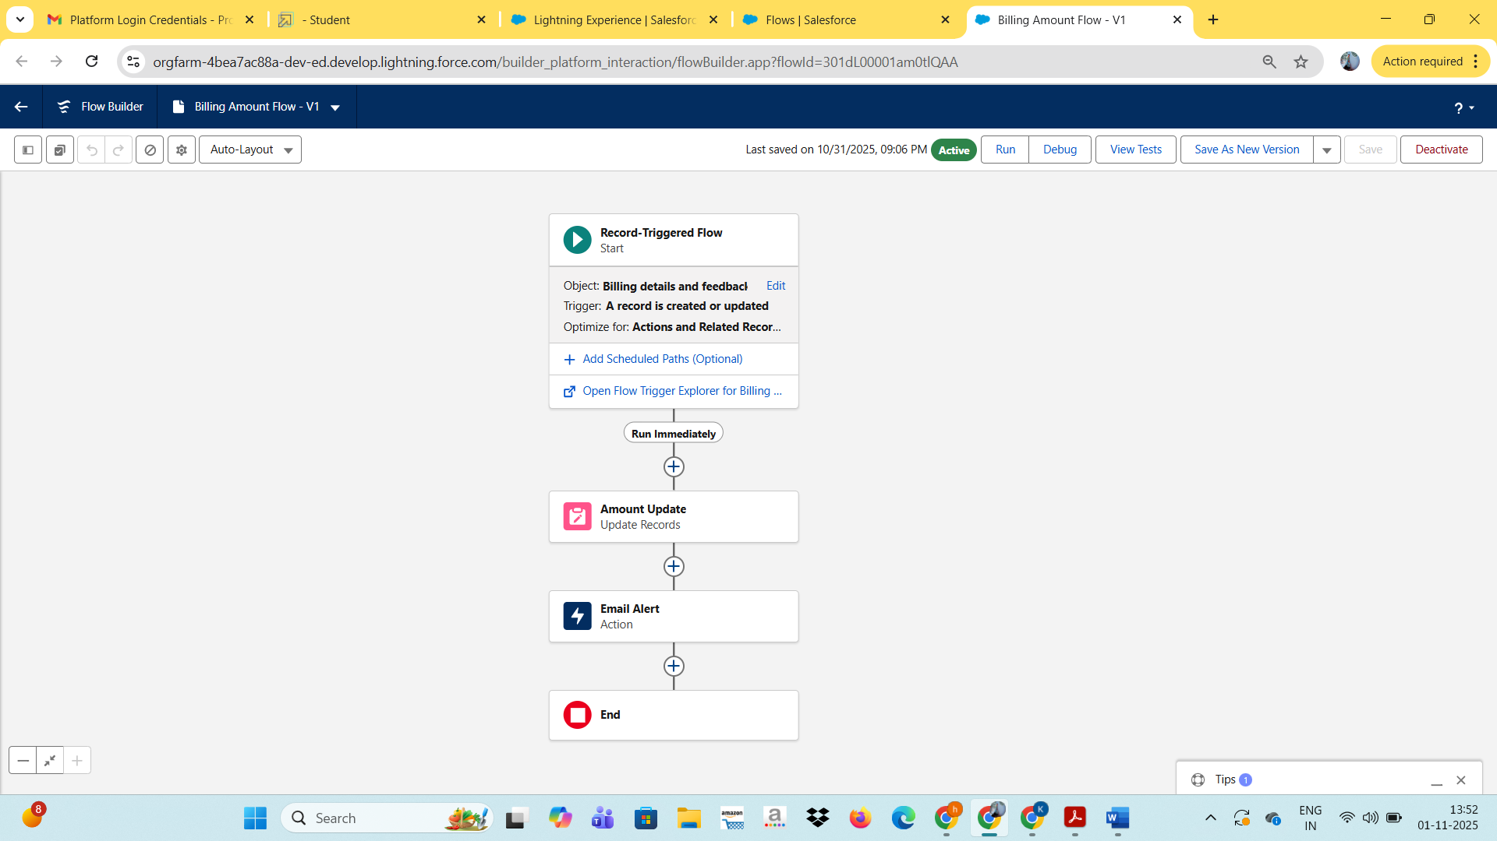

**Apex Trigger:**

Create a apex handler

1. Login to the respective trailhead account and navigate to the gear icon in the top right corner.
2. Click on the Developer console. Now you will see a new console window.
3. In the toolbar, you can see FILE. Click on it and navigate to new and create New apex class.
4. Name the class as “Amount Distribution Handler ”.

**Code:**

public class AmountDistributionHandler {

    public static void amountDist(list<Appointment__c> listApp){

        list<Service_records__c> serList = new list <Service_records__c>();

        for(Appointment__c app : listApp){

            if(app.Maintenance_service__c == true && app.Repairs__c == true && app.Replacement_Parts__c == true){

                app.Service_Amount__c = 10000;

            }

            else if(app.Maintenance_service__c == true && app.Repairs__c == true){

                app.Service_Amount__c = 5000;

            }

            else if(app.Maintenance_service__c == true && app.Replacement_Parts__c == true){

  app.Service_Amount__c = 8000;

            }

            else if(app.Repairs__c == true && app.Replacement_Parts__c == true){

                app.Service_Amount__c = 7000;

            }

            else if(app.Maintenance_service__c == true){

                app.Service_Amount__c = 2000;

            }

            else if(app.Repairs__c == true){

                app.Service_Amount__c = 3000;

            }

            else if(app.Replacement_Parts__c == true){

                app.Service_Amount__c = 5000;

            }

    }

    }

}

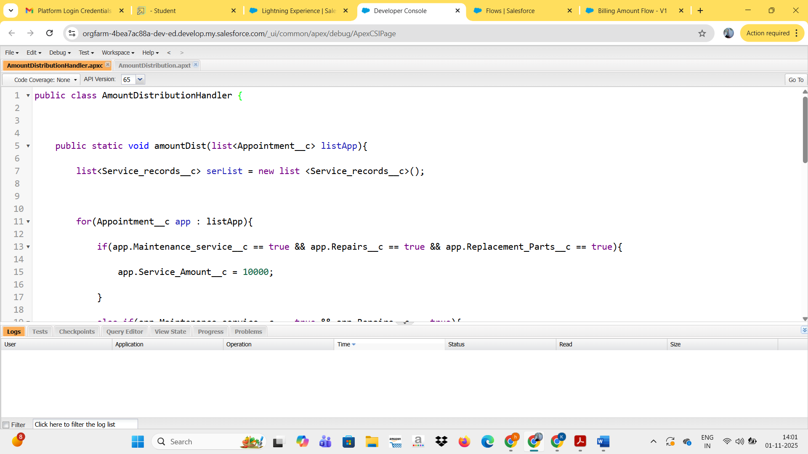

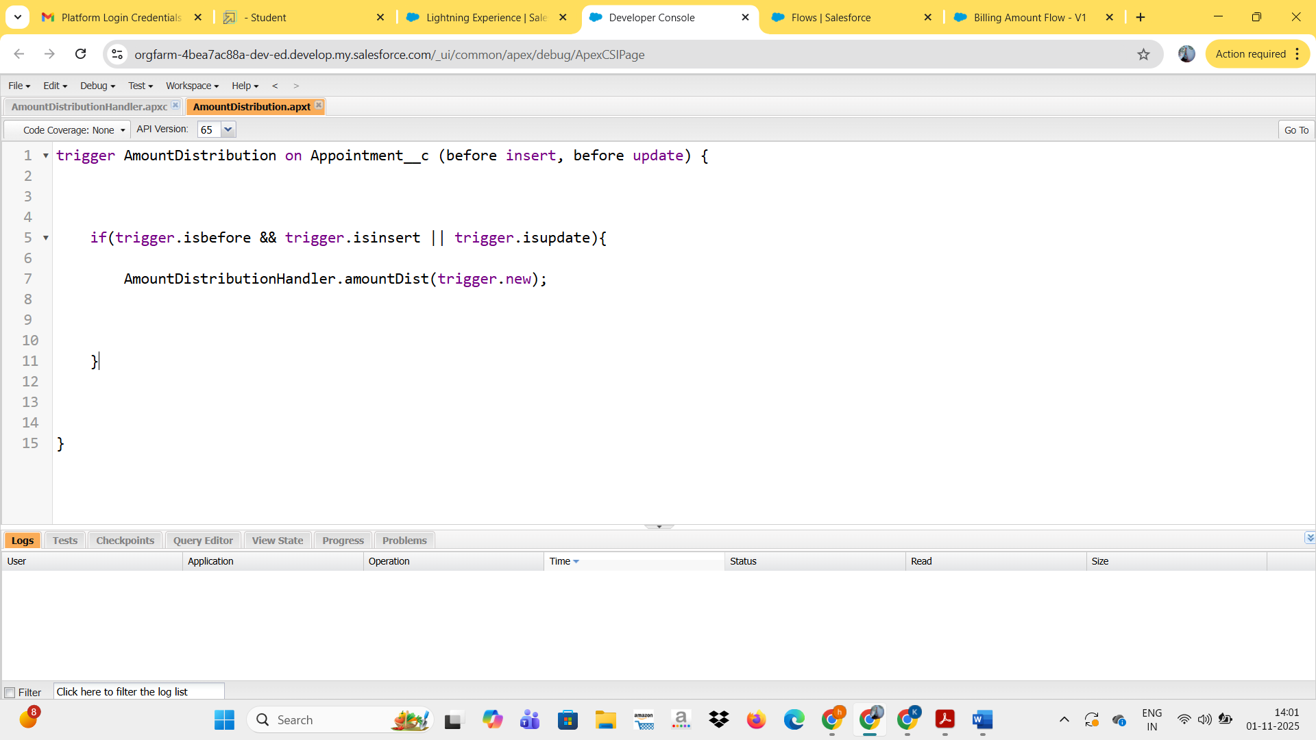

**Profiles:**

**To creating the manager profile**

1.Go to setup >>  type profiles in quick find box  >>  click on profiles  >>  clone the desired profile (Standard User)  >>  enter profile name (Manager)  >>  Save.

To creating the sales person profile

1. Go to setup >> type profiles in quick find box  >>  click on profiles  >>  clone the desired profile (Salesforce Platform User) >>  enter profile name (sales person)  >>  Save.

2.While still on the profile page, then click Edit.

3. Select the Custom App settings as default for the GArage management.

4. Scroll down to Custom Object Permissions and Give access permissions for Appointments,Billing details and feedback , service records and customer details objects as mentioned in the below diagram.

5.Click save.

**Users:**

Creation of users

1. Go to setup  >>  type users in quick find box  >>  select users  >> click New user.
2. Fill in the fields
3. First Name : Niklaus
4. Last Name : Mikaelson
5. Alias : Give a Alias Name
6. Email id : Give your Personal Email id
7. Username : Username should be in this form: text@text.text
8. Nick Name : Give a Nickname
9. Role : Manager
10. User licence : Salesforce
11. Profiles : Manager

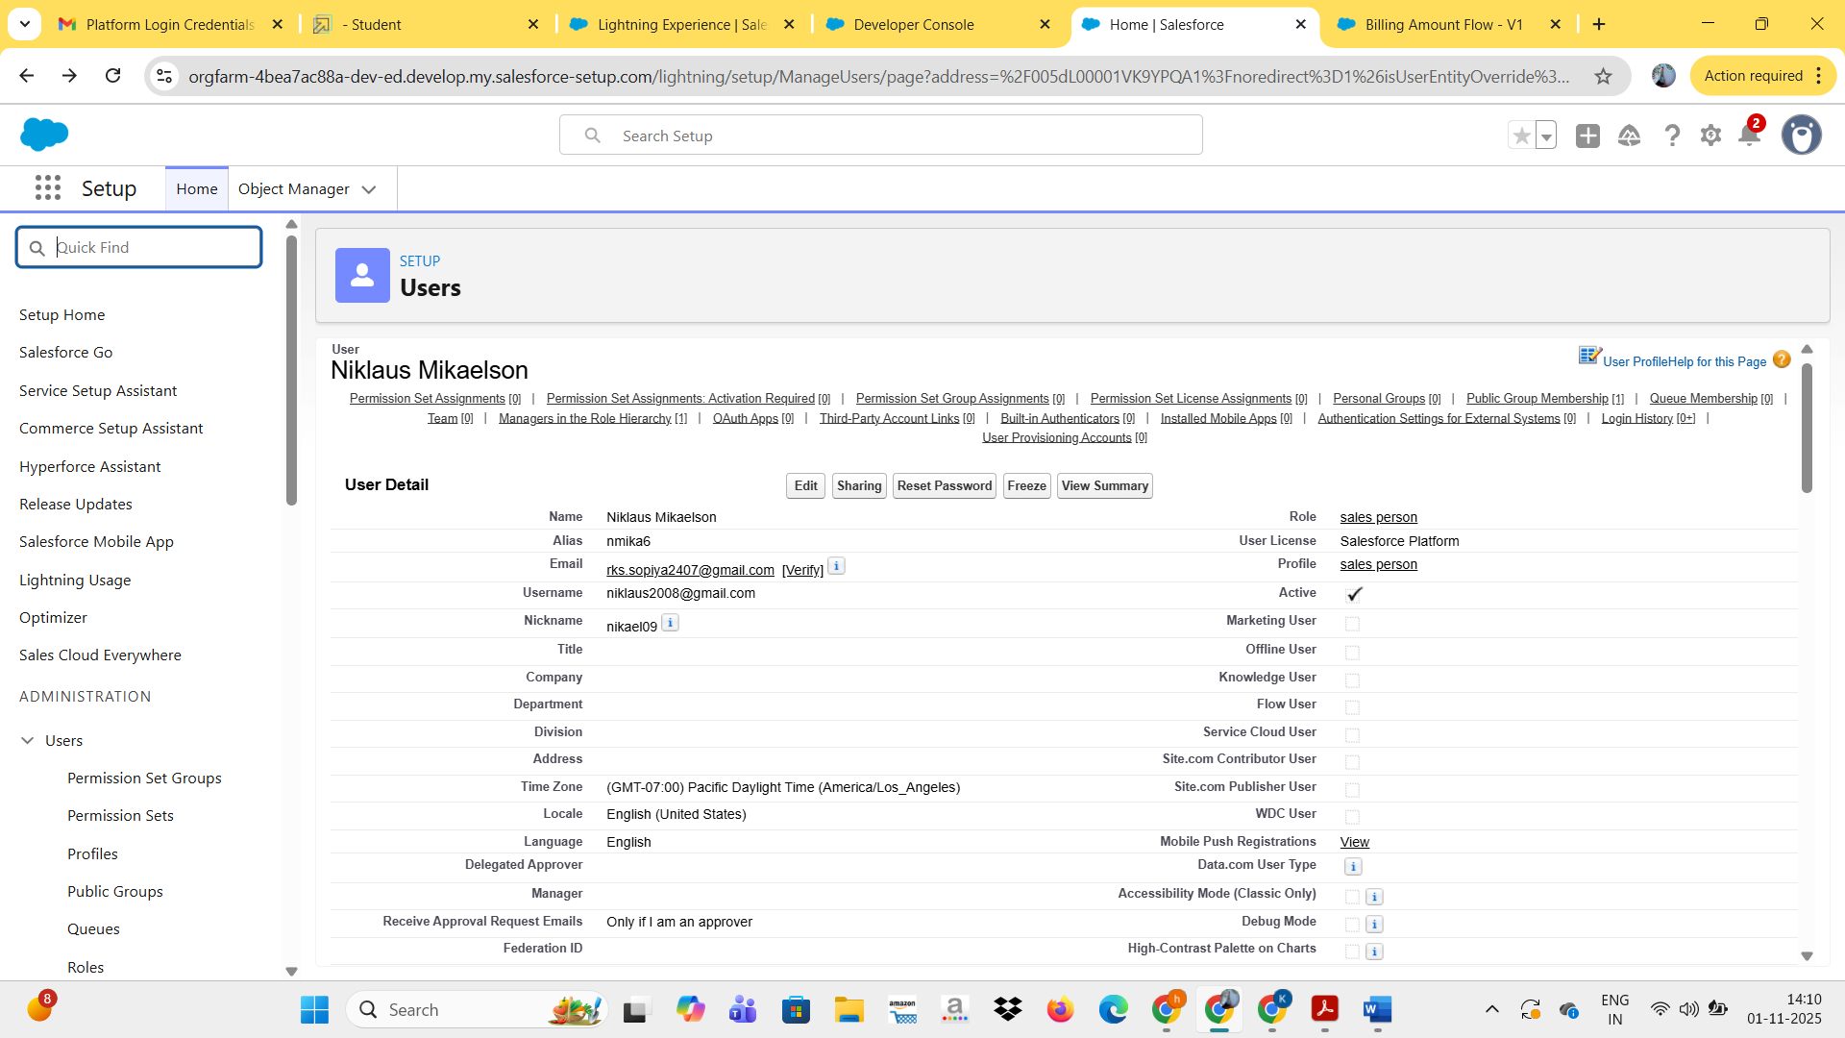

**Public groups:**

1. Go to setup  >>  type users in quick find box  >>  select public groups >> click New.

Under group information

1.Sales team

2.Niklaus mikaelson

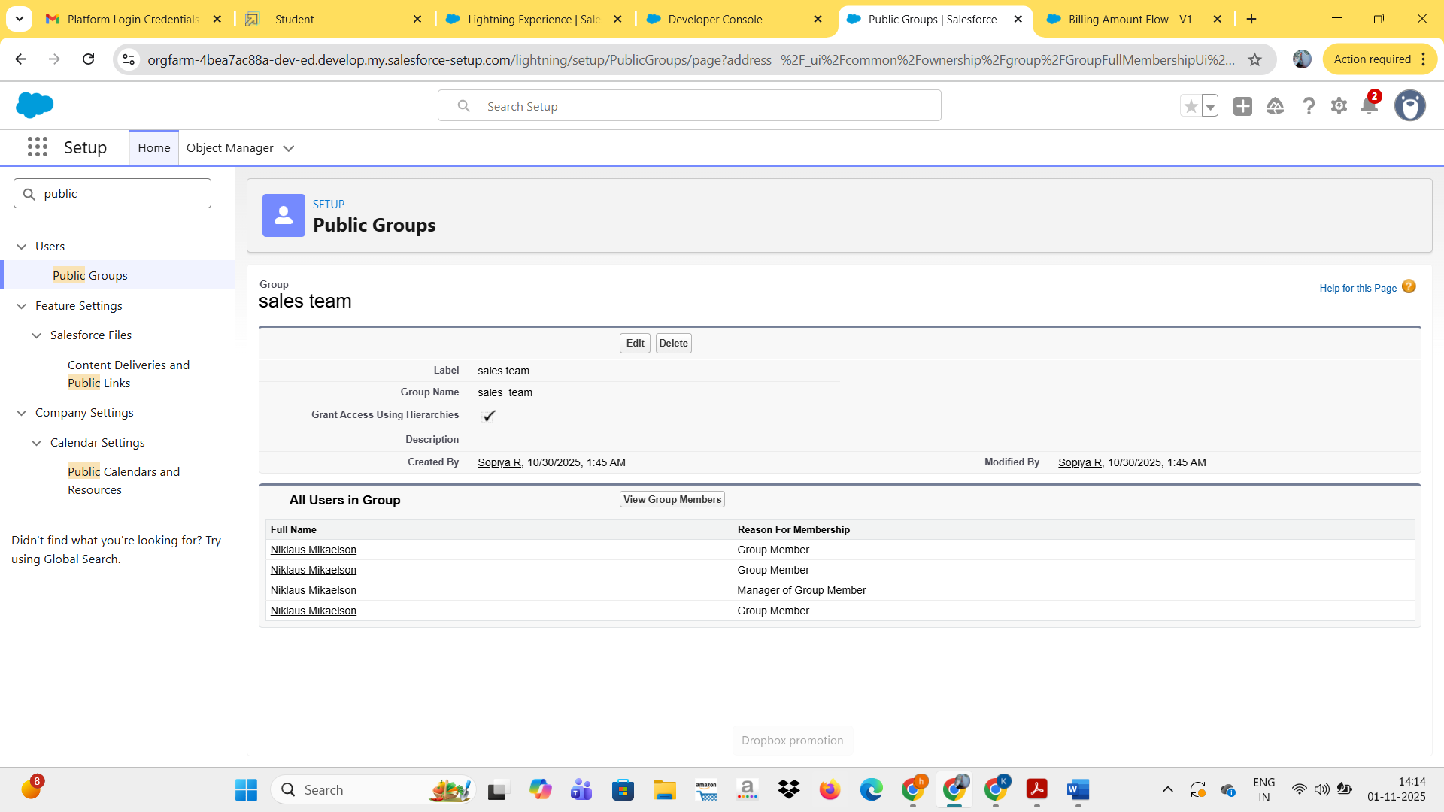

**Report Types:**

1. Go to setup  >>  type users in quick find box  >>  select Report Type >> click on Continue.
2. Click on new custom report type.

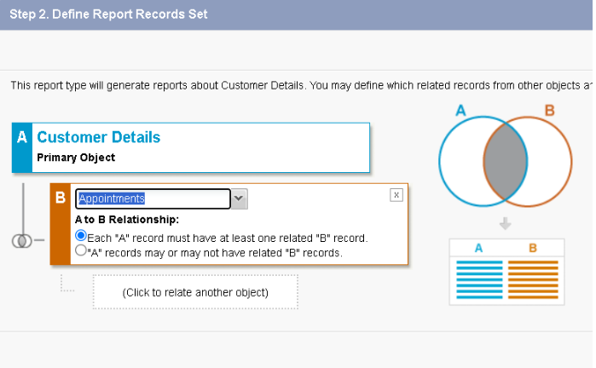

**Dashboards:**

1.Click on the app launcher and search for dashboard.

2.Click on dashboard tab.

3.Click new folder, give the folder label as “ Service Rating dashboard”.

4.Folder unique name will be auto populated.

5.Click save.

**Sharing Rules:**

Creation of sharing rules:

1. Go to setup >> type Sharing Settings in quick find box >> Click on the Sharing Settings

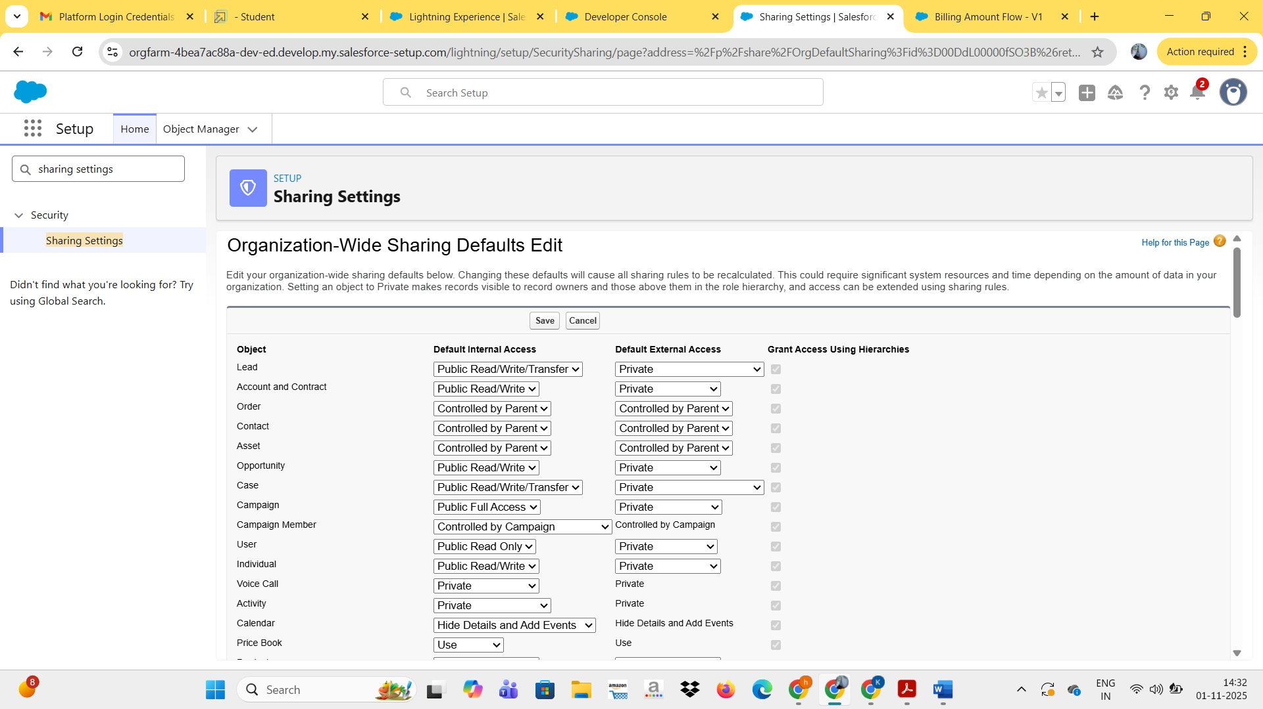

**Home Page :**

Creation of sharing rules:

1. Go to setup >> type Lightning App Builder in quick find box >> Click on the Lightning App Builder and Select the New.

2. Select Home Page and give Label as HOME Page.

3. Select Standard Home Page.

4. Near Components search for Flow and Drag and Drop in Right Side Section.

**Conclusion:**

The **Garage Management System in Salesforce** provides a smart, cloud-based solution to streamline and automate daily garage operations. By integrating key Salesforce features such as custom objects, automation tools, and real-time dashboards, the system enhances efficiency, accuracy, and customer satisfaction. It minimizes manual work, improves service tracking, and supports data-driven decision-making, ultimately helping garage owners manage their business more effectively and achieve sustainable growth.